Step-by-Step: Installing Estimating

| August-20 |

**Document Overview**

**Documentation Goals**

This documentation is intended to provide step by step instructions for ***Installation and Implementation of the Estimating system****.*

**Table of Contents**

**Implementation Overview** 3

**Implementation Sequence** 4

Step One: Enter Applicable Company Information 4

Step Two: Finished Good File Maintenance 5

Bin Locations by Warehouse 5

Plant & Warehouse 6

Product Categories 7

Step Three: System Administration – System Reference 8

Step Four: Estimating File Maintenance 8

Flute File 8

Stacking Matrix 9

Build Stack Matrix 10

Step Five: Raw Materials File Maintenance 11

Product Categories 11

Plant/Warehouse 12

Bin Locations by Warehouse 13

Material Cost Types 14

Raw Material Item File 15

Estimate Materials (Not Stocked) 16

Real Stocked Sheets and Rolls 17

Estimated Costs by Vendor for All Materials 18

Step Six: System Administration – More File Cleanup 19

Step Seven: Accounts Receivable File Maintenance 20

Customer Types 20

Territory 21

Terms File for Payment Terms 22

Salesman File 23

Sales Matrix for Commissions 24

Common Carrier Matrix 25

Customer File 26

Ship-To Folder for Ship Codes 26

Add Truck and Shipping Information 27

Sold-To Folder for Sold-To Codes 31

Step Eight: Estimating File Maintenance 31

Machine File 31

Machine Standards 32

Machine Routings 33

Box Designs for New Designs 34

Folding Style File 35

Corrugated Style File 36

Flute Style and Score Allowances 37

Routing Matrix Folder 38

Prep and Die File 39

Estimate Control File 40

Step Nine: Job Cost File 41

Product Line File 41

Product Categories for Each Product Line 41

Order Entry Control File 42

Price Matrix 43

Step Ten: Purchase Order File Maintenance 44

Purchasing Control File 44

Reject Reason File 44

Step Eleven: Job Cost Control File 45

Job Cost Control File 45

Product Line File for General Ledger Accounts 45

Machine Charge Code File 46

# **Implementation Overview**

Implementationof our software first requires building and changing many files through each module. Each module has a file maintenance menu where all the files are located for that module.

Please Note: Initial installations include a database downloaded by Advanced Software, Inc. The following files have been loaded with industry standard:

|  |  |  |  |
| --- | --- | --- | --- |
| Bin Locations | Box Designs | Flute File | Machines |
| Machine Standards | One Customer | Plant Locations | Product Category |
| Raw Materials | Stacking Codes | Stacking Matrix | Styles |

Although the above files have been installed, the customer should view and modify each file according to their specifications. Once defined, estimates may be created for folding cartons, corrugated boxes, foam, sets, point of purchase displays and more.

Each estimate may have unlimited die and sheet sizes, which are known as forms throughout our system. Each form (sheet size) may have unlimited blanks (items). Corrugated estimates may be for single item boxes or for sets.

Folding carton estimates may be for single item boxes, sets or combination jobs, which may be for multiple forms and unlimited items per form.

# **Implementation Sequence**

## Step One: Enter Applicable Company Information

The *Company* screen is located in the following Menu Path: General Ledger -> File Maintenance for G/L -> Company. Alternatively, the user can quickly get to this screen using the Hot Key combination: ***[“G” – “F” – “1”]***.

The user should now enter or adjust any applicable customer information.

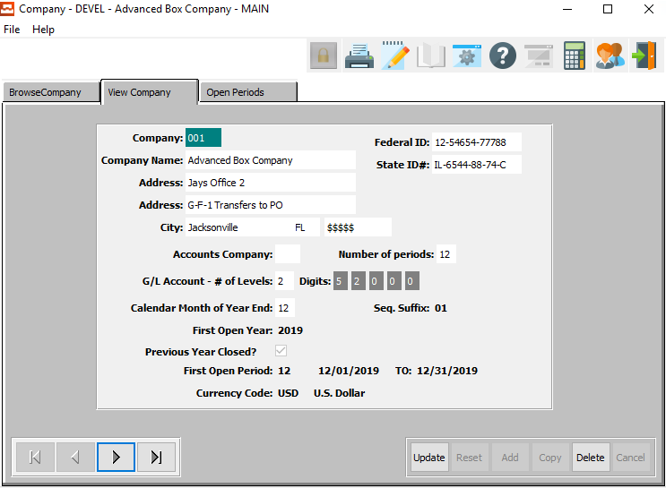

## Step Two: Finished Good File Maintenance

The user should now enter or update any applicable information for the following:

|  |  |  |
| --- | --- | --- |
| Bin Locations by Warehouse | Plant & Warehouse | Product Categories |

### Bin Locations by Warehouse

The *Bin Locations by Warehouse* screen is located in the following Menu Path: Inventory/Finished Goods -> File Maintenance for Items -> Warehouse/Bin Locations. Alternatively, the user can quickly get to this screen using the Hot Key combination: ***[“I” – “F” – “4”]***.

Finished Goods Bins are specifically located on the *F/G Bins* tab.

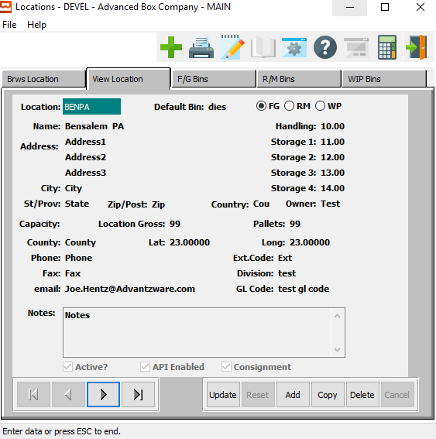

### Plant & Warehouse

The *Warehouse Locations* screen is located in the following Menu Path: Inventory/Finished Goods -> File Maintenance for Items -> Warehouse/Bin Locations. Alternatively, the user can quickly get to this screen using the Hot Key combination: ***[“I” – “F” – “4”]***.

Finished Goods Bins are specifically located on the *F/G Bins* tab.



### Product Categories

The *Finished Goods Categories* screen is located in the following Menu Path: Inventory/Finished Goods -> File Maintenance for Items -> Finished Goods Categories. Alternatively, the user can quickly get to this screen using the Hot Key combination: ***[“I” – “F” – “3”]***.

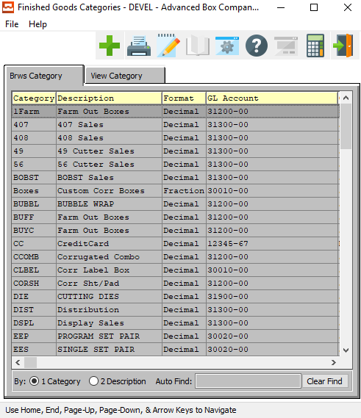

## Step Three: System Administration – System Reference

System Reference Files located under the [***“N”-“S”***] hotkeys.

* Department File
  + Delete departments that are not required.
  + Do not change excising codes.
  + Add codes for unique business requirements.

## Step Four: Estimating File Maintenance

Please Note: This step is for Corrugated plants only.

The *Flute and Unit Counts* screen is located in the following Menu Path: Estimating/Quotes -> Build Estimate Files -> Flute and Unit Counts. Alternatively, the user can quickly get to this screen using the Hot Key combination: ***[“E” – “B” – “7”]***.

### Flute File

Open the *Flute File* to add and delete flutes for the plant.

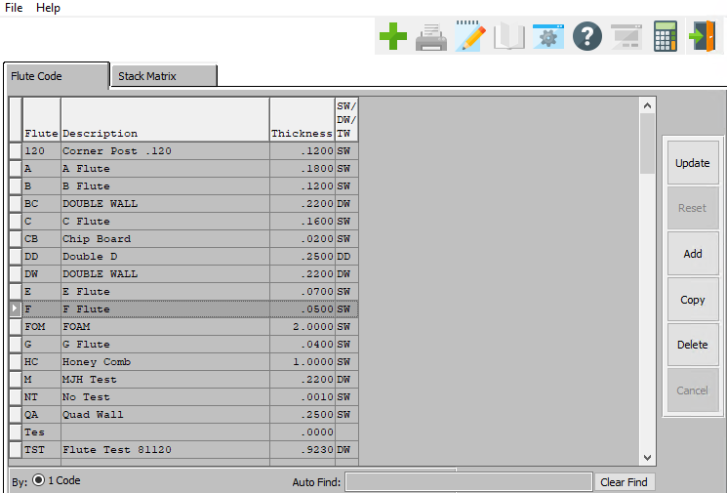

#### ADD

To add a new Flute, simply click the ***“Green + Icon”*** button at the right of the *Flute Code* screen.

Alternatively, click the ***“Add”*** button at the bottom of the screen.

#### DELETE

To delete the currently selected Flute, simply press the ***"D"*** key. Alternatively, click the ***“Delete”*** button at the right of the screen.

### Stacking Matrix

The *Stacking Matrix* folder houses unit counts that the system will build.

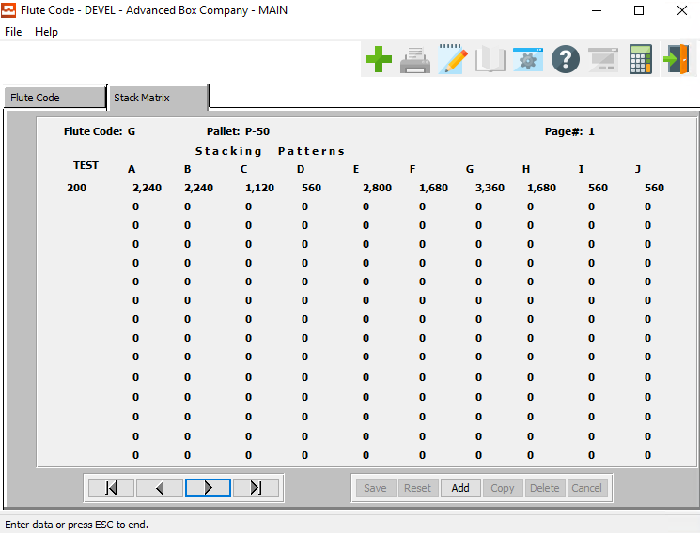

#### ADD

Click the ***“Add”*** button at the bottom of the screen to add a new Stack Matrix.

### Build Stack Matrix

After adding all Board Raw Materials, the user should run the program to build the stack matrix.

The *Build Flute/Test Counts* screen is located in the following Menu Path: Network/System Administrator -> Y More File Cleanup -> Build Flute/Test Counts. Alternatively, the user can quickly get to this screen using the Hot Key combination: ***[“N” – “Y” – “5”]***.

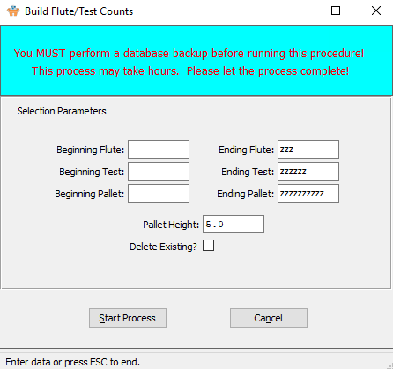

## Step Five: Raw Materials File Maintenance

Raw Material File Maintenance programs are located under the [***“M”-“F”***] hotkeys.

### Product Categories

The *Product Categories* screen is located in the following Menu Path: Materials/Raw Goods -> File Maintenance for Raw Goods -> Raw Materials Categories. Alternatively, the user can quickly get to this screen using the Hot Key combination: ***[“M” – “F” – “3”]***.

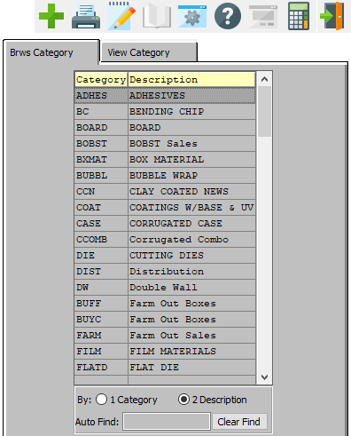

### Plant/Warehouse

The *Warehouse Locations* screen is located in the following Menu Path: Inventory/Finished Goods -> File Maintenance for Items -> Warehouse/Bin Locations. Alternatively, the user can quickly get to this screen using the Hot Key combination: ***[“I” – “F” – “4”]***.

Raw Material Bins are specifically located on the *R/M Bins* tab.



### Bin Locations by Warehouse

The *Bin Locations by Warehouse* screen is located in the following Menu Path: Inventory/Finished Goods -> File Maintenance for Items -> Warehouse/Bin Locations. Alternatively, the user can quickly get to this screen using the Hot Key combination: ***[“I” – “F” – “4”]***.

Raw Material Bins are specifically located on the *R/M Bins* tab.



### Material Cost Types

Please Note: This is only needed if using General Ledger numbers in Job Costing.

The *Material Cost Types* screen is located in the following Menu Path: Materials/Raw Goods -> File Maintenance for Raw Goods -> Material Cost Types. Alternatively, the user can quickly get to this screen using the Hot Key combination: ***[“M” – “F” – “4”]***.

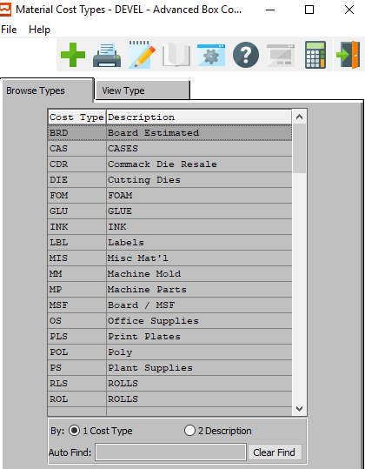

### Raw Material Item File

This is for Board, Inks, Cases, Pallets, Adders, etc.

#### Folding Carton Materials

The *Raw Materials Inventory* screen is located in the following Menu Path: Materials/Raw Goods -> File Maintenance for Raw Goods -> Folding Carton Materials. Alternatively, the user can quickly get to this screen using the Hot Key combination: ***[“M” – “F” – “1”]***.

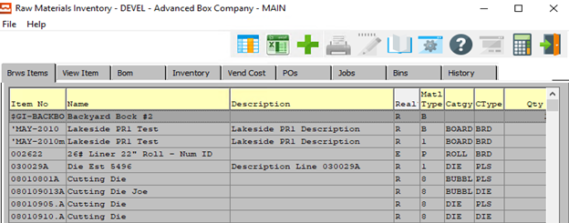

#### Corrugated/Foam Materials

The *Raw Materials (Corrugated)* screen is located in the following Menu Path: Materials/Raw Goods -> File Maintenance for Raw Goods -> Corrugated/Foam Materials. Alternatively, the user can quickly get to this screen using the Hot Key combination: ***[“M” – “F” – “2”]***.

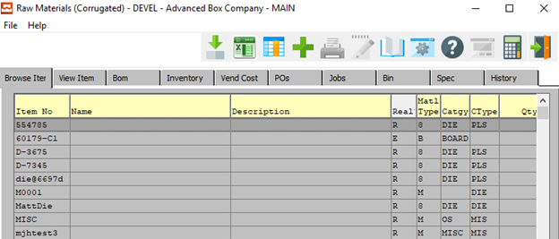

### Estimate Materials (Not Stocked)

To mark an item as a non-stocked ***“Estimated Material”***, the user should make sure that the *Estimated Mat’l* choice bubble is toggled in the *Item Detail* screen.

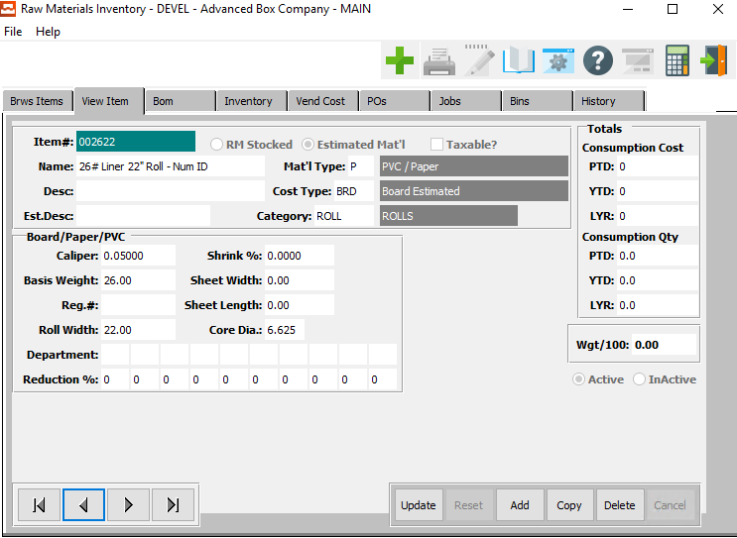

### Real Stocked Sheets and Rolls

To mark an item as ***“Stocked”***, the user should make sure that the *RM Stocked* choice bubble is toggled in the *Item Detail* screen.

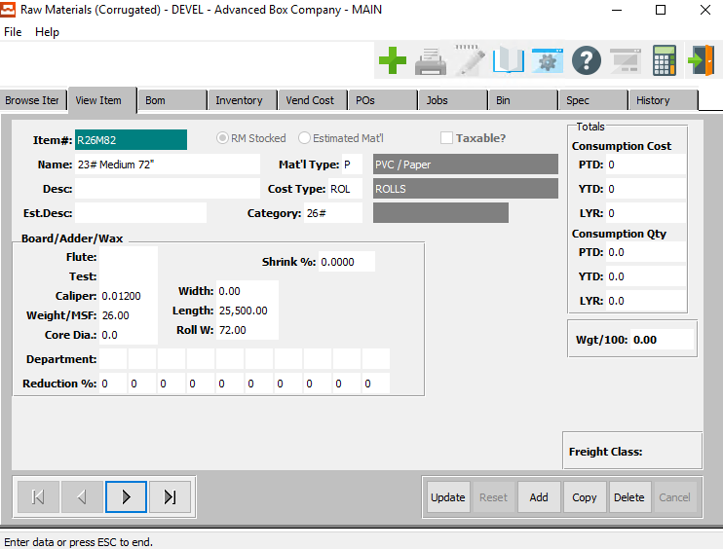

### Estimated Costs by Vendor for All Materials

The *Vendor Cost Matrix* screen is located in the following Menu Path: Purchasing -> File Maintenance for Purchasing -> Vendor Cost Matrix. Alternatively, the user can quickly get to this screen using the Hot Key combination: ***[“P” – “F” – “3”]***.

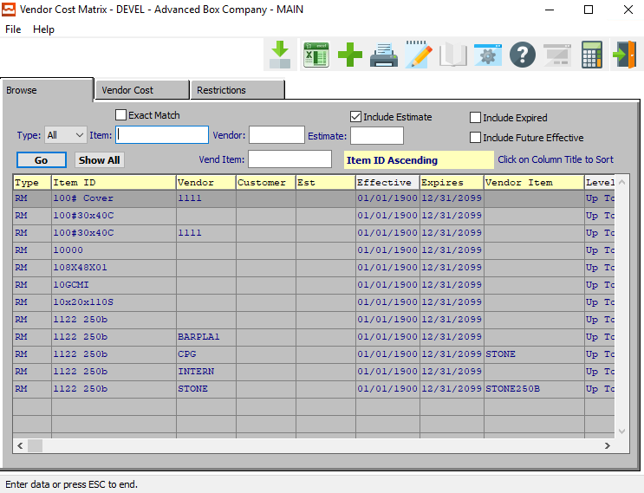

## Step Six: System Administration – More File Cleanup

Please Note: This step is for Corrugated plants only.

The *Build Flute/Test Counts* screen is located in the following Menu Path: Network/System Administrator -> Y More File Cleanup -> Build Flute/Test Counts. Alternatively, the user can quickly get to this screen using the Hot Key combination: ***[“N” – “Y” – “5”]***.

This system will build unit counts in the flute. It uses the caliper thickness of each estimated board material.



## Step Seven: Accounts Receivable File Maintenance

Accounts Receivable File Maintenance programs are located under the [***“A”-“F”***] hotkeys.

### Customer Types

The *Customer Types* screen is located in the following Menu Path: Accounts Receivable -> File Maintenance for Customers -> Customer Types. Alternatively, the user can quickly get to this screen using the Hot Key combination: ***[“A” – “F” – “2”]***.

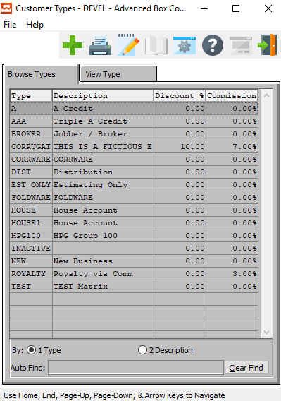

### Territory

The *Territory* screen is located in the following Menu Path: Accounts Receivable -> File Maintenance for Customers -> Sales Territories. Alternatively, the user can quickly get to this screen using the Hot Key combination: ***[“A” – “F” – “5”]***.

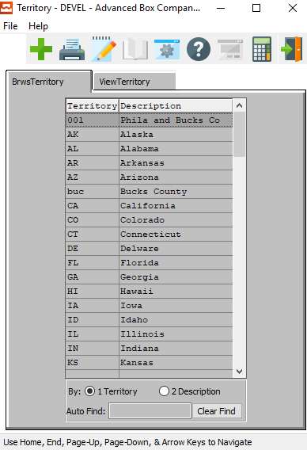

### Terms File for Payment Terms

The *Terms* screen is located in the following Menu Path: Accounts Receivable -> File Maintenance for Customers -> Payment Terms. Alternatively, the user can quickly get to this screen using the Hot Key combination: ***[“A” – “F” – “4”]***.

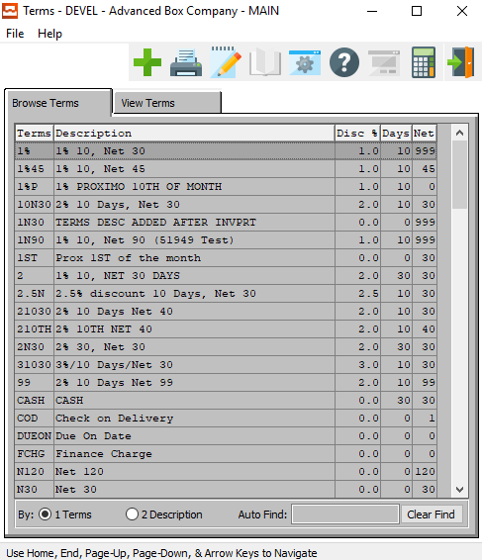

### Salesman File

The *Sales Group* screen is located in the following Menu Path: Accounts Receivable -> File Maintenance for Customers -> Sales Rep/Commissions. Alternatively, the user can quickly get to this screen using the Hot Key combination: ***[“A” – “F” – “3”]***.

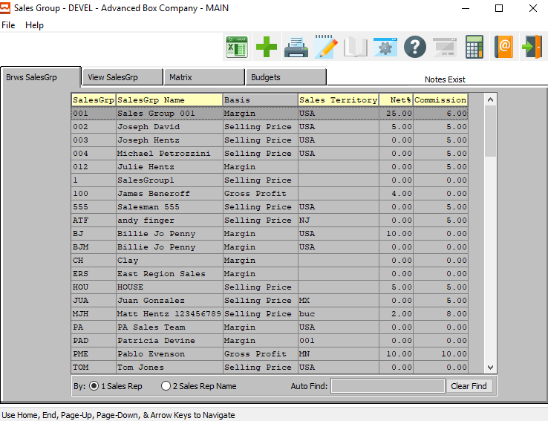

### Sales Matrix for Commissions

The *Sales Group* screen is located in the following Menu Path: Accounts Receivable -> File Maintenance for Customers -> Sales Rep/Commissions. Alternatively, the user can quickly get to this screen using the Hot Key combination: ***[“A” – “F” – “3”]***.

Sales Matrix details are specifically located on the *Matrix* tab.

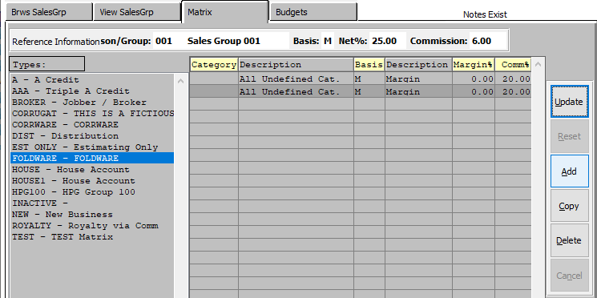

#### By Customer Type

The user should choose a type from the list located along the left side of the screen. In order to choose a type, the user may click on their desired type in order to highlight it within the list of available types.

#### By Category

The user must now enter the Category they wish to base this new Matrix on. If the user knows the Category that they wish to use, they may enter it manually in the *Category* field.

Alternatively, the user can press the ***“F1”*** key to choose a category from a list of available Finished Good Product Category Information.

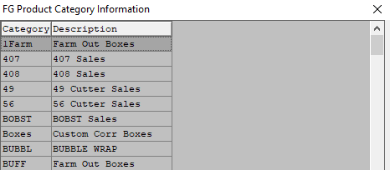

### Common Carrier Matrix

The *Common Carriers* screen is located in the following Menu Path: Accounts Receivable -> File Maintenance for Customers -> Truck/Common Carriers. Alternatively, the user can quickly get to this screen using the Hot Key combination: ***[“A” – “F” – “8”]***.

Common Carrier Matrix details are specifically located on the *Matrix* tab.

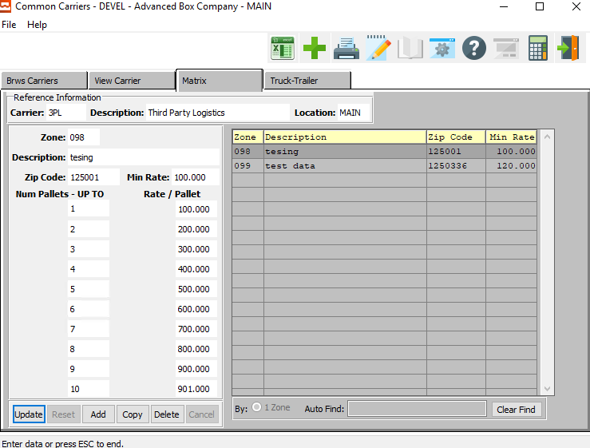

### Customer File

Please Note: All files above are required in order accurately create a customer file.

The *Customer File Maintenance* screen is located in the following Menu Path: Accounts Receivable -> File Maintenance for Customers -> Customers. Alternatively, the user can quickly get to this screen using the Hot Key combination: ***[“A” – “F” – “1”]***.

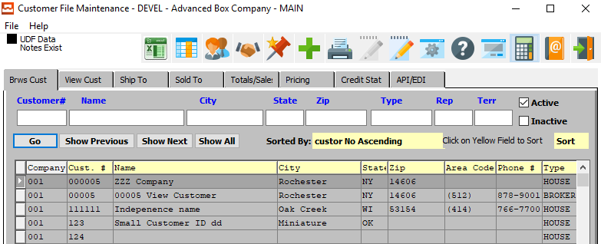

### Ship-To Folder for Ship Codes

The *Customer File Maintenance* screen is located in the following Menu Path: Accounts Receivable -> File Maintenance for Customers -> Customers. Alternatively, the user can quickly get to this screen using the Hot Key combination: ***[“A” – “F” – “1”]***.

Ship-To and Sold-To details are specifically located on the *Ship-To* and *Sold-To* tabs, respectively.

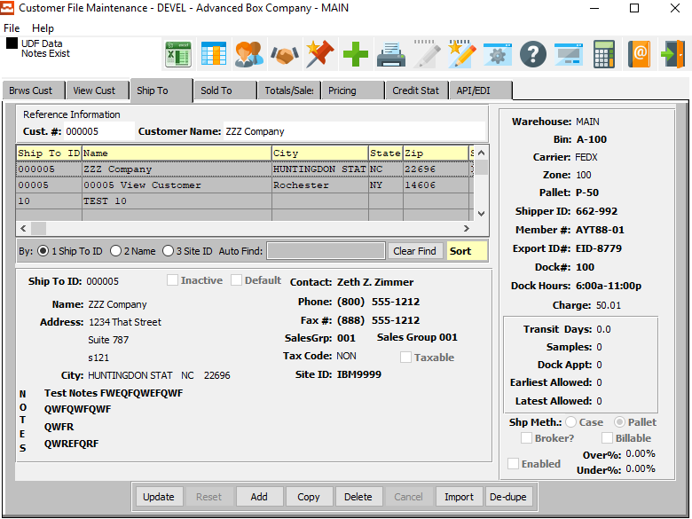

### Add Truck and Shipping Information

#### Add Address

The *Customer File Maintenance* screen is located in the following Menu Path: Accounts Receivable -> File Maintenance for Customers -> Customers. Alternatively, the user can quickly get to this screen using the Hot Key combination: ***[“A” – “F” – “1”]***.

Ship-To address details are specifically located on the *Ship-To* tab.



#### Add Truck Code

The *Common Carriers* screen is located in the following Menu Path: Accounts Receivable -> File Maintenance for Customers -> Truck/Common Carriers. Alternatively, the user can quickly get to this screen using the Hot Key combination: ***[“A” – “F” – “8”]***.

Truck and trailer details are specifically located on the *Truck-Trailer* tab.

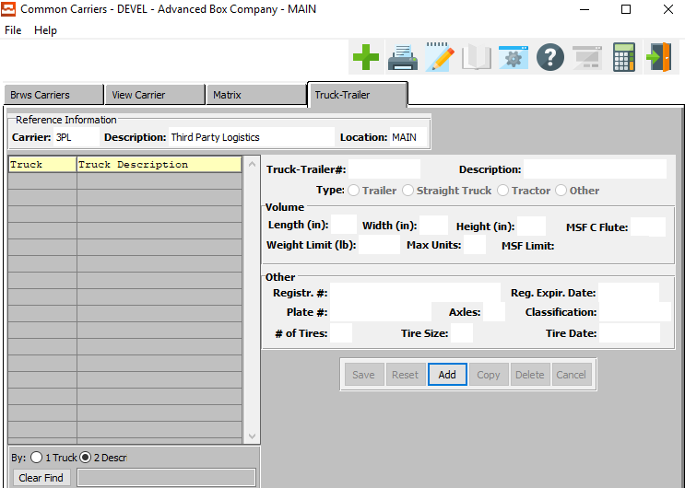

#### Add Delivery Zone

The *Common Carriers* screen is located in the following Menu Path: Accounts Receivable -> File Maintenance for Customers -> Truck/Common Carriers. Alternatively, the user can quickly get to this screen using the Hot Key combination: ***[“A” – “F” – “8”]***.

Delivery Zone details are specifically located on the *Matrix* tab.



#### Add Ship Notes

The *Customer File Maintenance* screen is located in the following Menu Path: Accounts Receivable -> File Maintenance for Customers -> Customers. Alternatively, the user can quickly get to this screen using the Hot Key combination: ***[“A” – “F” – “1”]***.

Customer and shipping notes are found by pressing the ***“Starred Pencil and Paper Icon”*** button at the top of the screen.

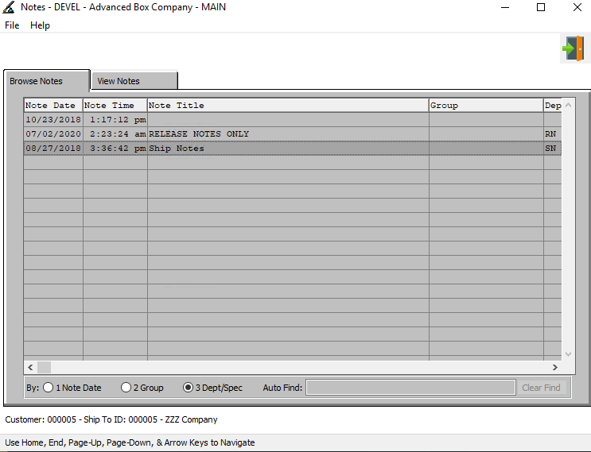

### Sold-To Folder for Sold-To Codes

The *Customer File Maintenance* screen is located in the following Menu Path: Accounts Receivable -> File Maintenance for Customers -> Customers. Alternatively, the user can quickly get to this screen using the Hot Key combination: ***[“A” – “F” – “1”]***.

Sold-To details are specifically located on the *Sold-To* tab.

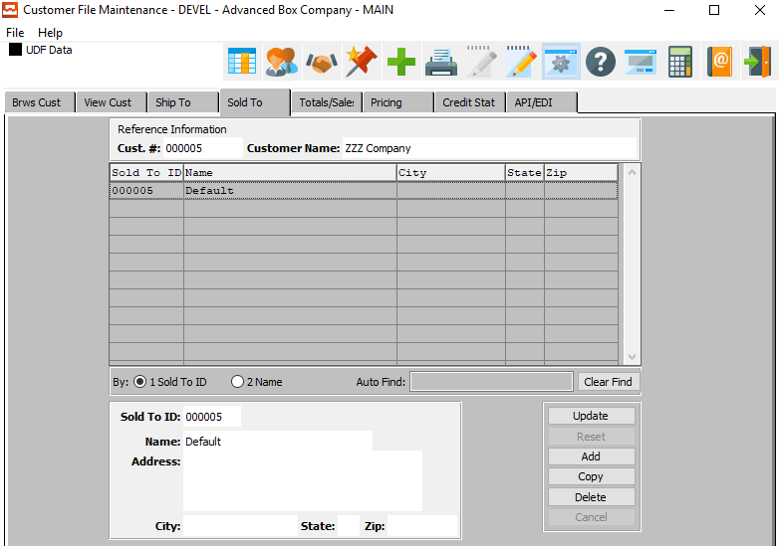

## Step Eight: Estimating File Maintenance

Estimating File Maintenance programs are located under the [***“E”-“B”***] hotkeys.

### Machine File

The *Machine File* screen is located in the following Menu Path: Estimating/Quotes -> Build Estimate Files -> Machine File. Alternatively, the user can quickly get to this screen using the Hot Key combination: ***[“E” – “B” – “1”]***

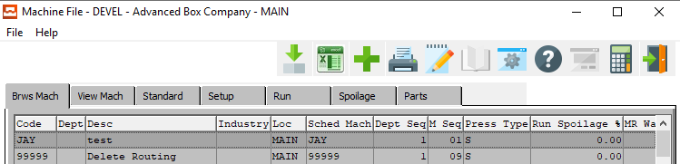

### Machine Standards

Machine standards for Setup, Run, and Spoilage

The *Machine File* screen is located in the following Menu Path: Estimating/Quotes -> Build Estimate Files -> Machine File. Alternatively, the user can quickly get to this screen using the Hot Key combination: ***[“E” – “B” – “1”]***

Machine Standard details are specifically located on the *Standard* tab.

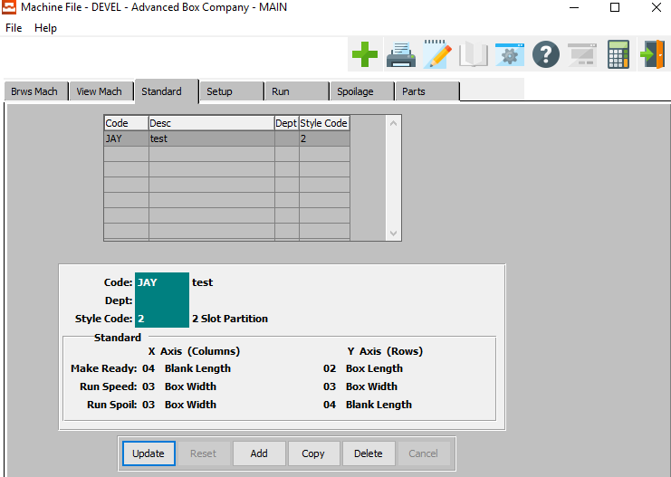

### Machine Routings

Please Note: This step is for Corrugated plants only.

The *Corr Machine Routing* screen is located in the following Menu Path: Estimating/Quotes -> Build Estimate Files -> Machine Routings. Alternatively, the user can quickly get to this screen using the Hot Key combination: ***[“E” – “B” – “!”]***

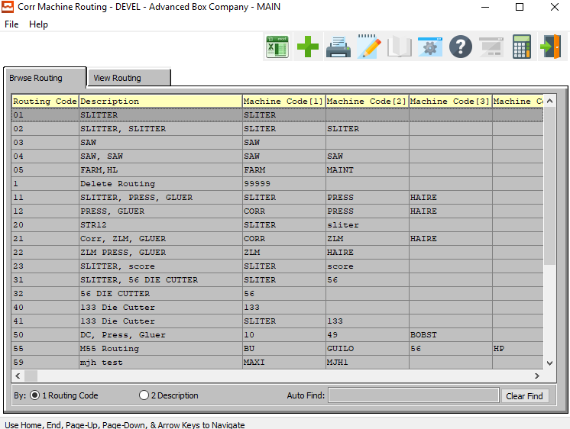

### Box Designs for New Designs

The *Corrugated Box Design* screen is located in the following Menu Path: Estimating/Quotes -> Build Estimate Files -> Box Designs. Alternatively, the user can quickly get to this screen using the Hot Key combination: ***[“E” – “B” – “4”]***

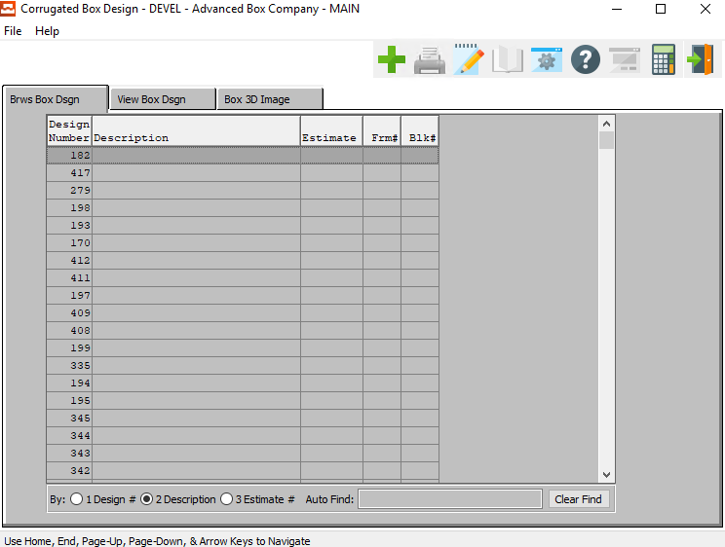

### Folding Style File

The *Folding Style* screen is located in the following Menu Path: Estimating/Quotes -> Build Estimate Files -> Folding Styles. Alternatively, the user can quickly get to this screen using the Hot Key combination: ***[“E” – “B” – “2”]***

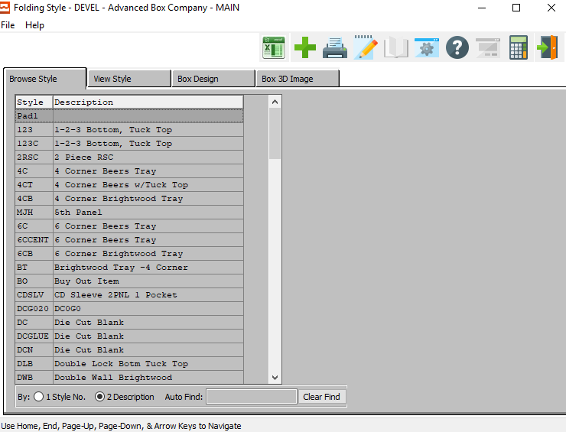

#### Default Dimensions/Layout Formulas

The user should make sure to define all *default dimensions* and *layout formulas* on the Style detail screen, located on the *View Style* tab.

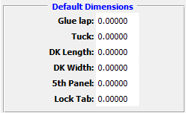 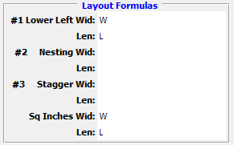

### Corrugated Style File

The *Corrugated Style* screen is located in the following Menu Path: Estimating/Quotes -> Build Estimate Files -> Corrugated Styles. Alternatively, the user can quickly get to this screen using the Hot Key combination: ***[“E” – “B” – “3”]***

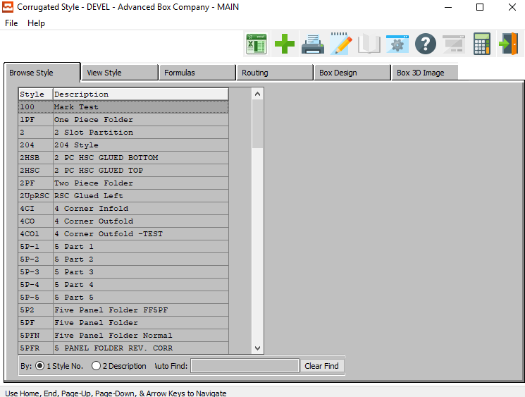

### Flute Style and Score Allowances

Build/Change styles and score allowances for each Flute.

The *Flute Code* screen is located in the following Menu Path: Estimating/Quotes -> Build Estimate Files -> Flute and Unit Counts. Alternatively, the user can quickly get to this screen using the Hot Key combination: ***[“E” – “B” – “7”]***

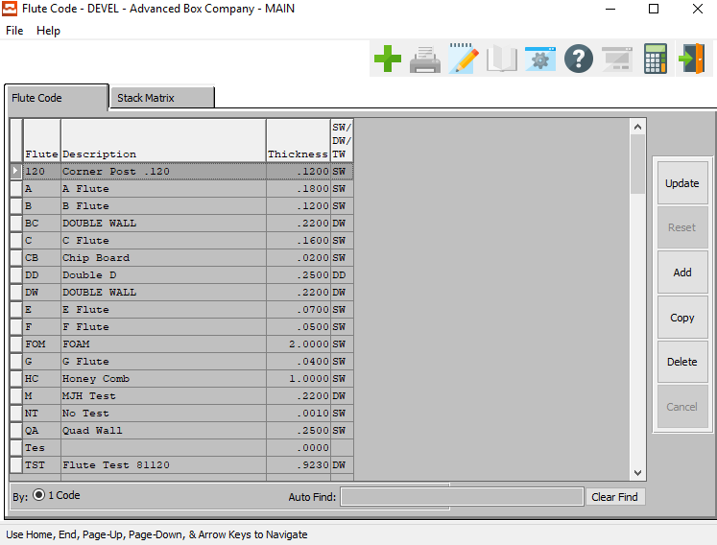

### Routing Matrix Folder

Routing Matrix folder for automatic machine routing by style.

The *Corr Machine Routing* screen is located in the following Menu Path: Estimating/Quotes -> Build Estimate Files -> Machine Routings. Alternatively, the user can quickly get to this screen using the Hot Key combination: ***[“E” – “B” – “!”]***

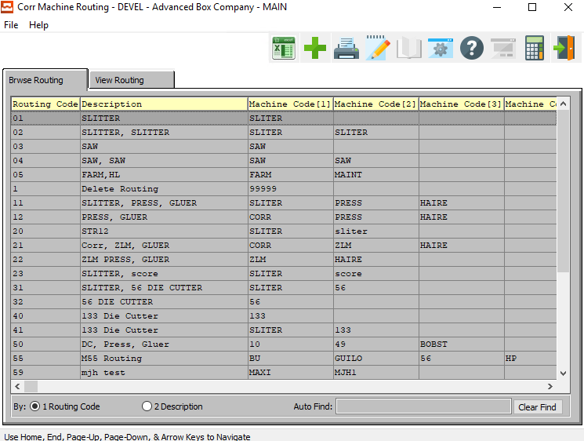

### Prep and Die File

The *Prep and Die File* screen is located in the following Menu Path: Estimating/Quotes -> Build Estimate Files -> Prep and Die File. Alternatively, the user can quickly get to this screen using the Hot Key combination: ***[“E” – “B” – “8”]***

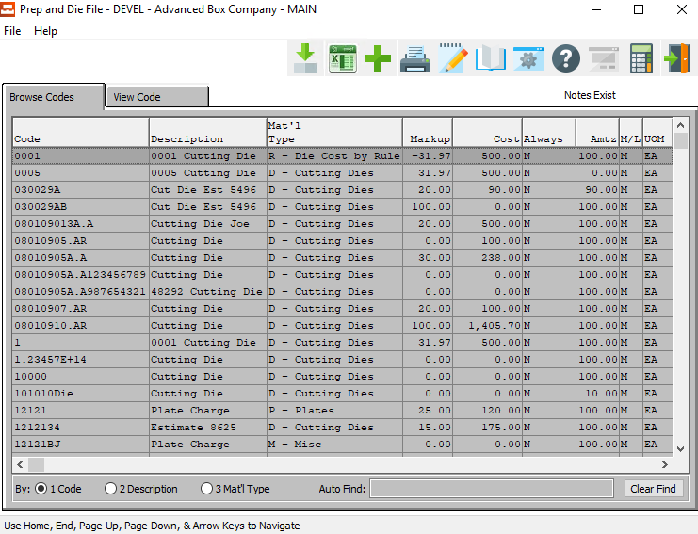

### Estimate Control File

The *Cost Estimating Control* screen is located in the following Menu Path: Estimating/Quotes -> Build Estimate Files -> Cost Estimate Control. Alternatively, the user can quickly get to this screen using the Hot Key combination: ***[“E” – “B” – “9”]***

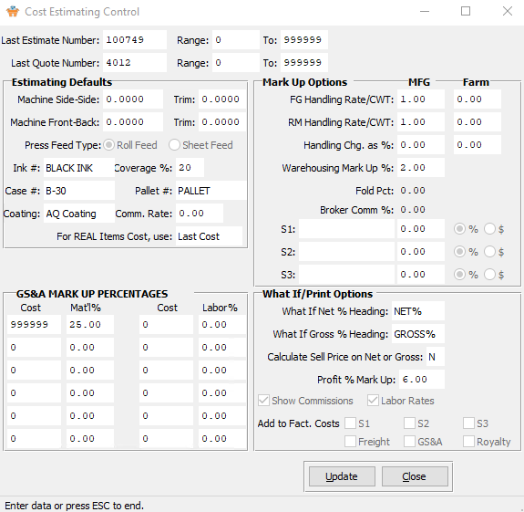

## Step Nine: Job Cost File

### Product Line File

The *Product Line GL Accounts* screen is located in the following Menu Path: Job Costing -> File Maintenance for Jobs -> Product Line GL Accounts. Alternatively, the user can quickly get to this screen using the Hot Key combination: ***[“J” – “F” – “3”]***.

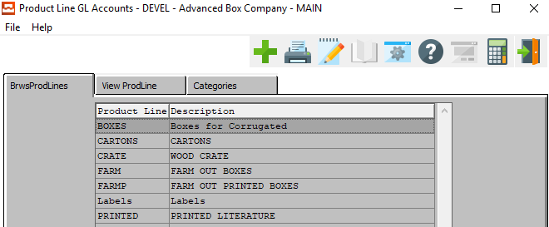

### Product Categories for Each Product Line

The *Product Line GL Accounts* screen is located in the following Menu Path: Job Costing -> File Maintenance for Jobs -> Product Line GL Accounts. Alternatively, the user can quickly get to this screen using the Hot Key combination: ***[“J” – “F” – “3”]***.

Product Category details are specifically located on the *Categories* tab.

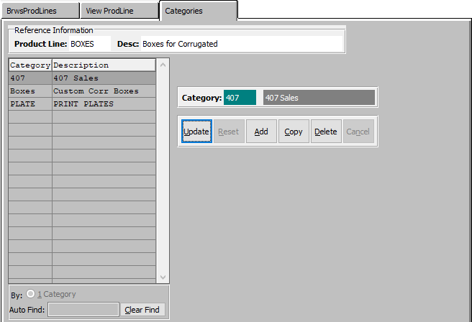

### Order Entry Control File

The *Order Processing Control* screen is located in the following Menu Path: Order Processing -> File Maintenance for Orders -> Order Entry Control. Alternatively, the user can quickly get to this screen using the Hot Key combination: ***[“O” – “F” – “2”]***.

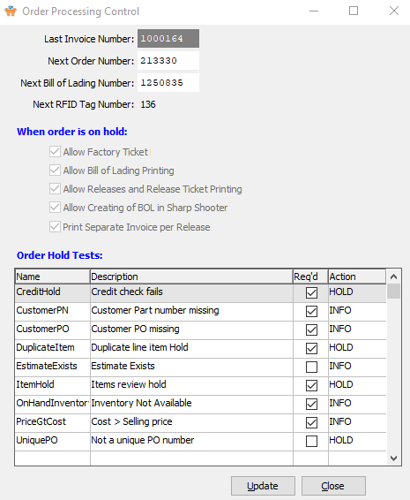

### Price Matrix

Please Note: This is for Stock Box and Distribution items only.

The *Price Matrix* screen is located in the following Menu Path: Order Processing -> File Maintenance for Orders -> Sales Price Matrix. Alternatively, the user can quickly get to this screen using the Hot Key combination: ***[“O” – “F” – “3”]***.

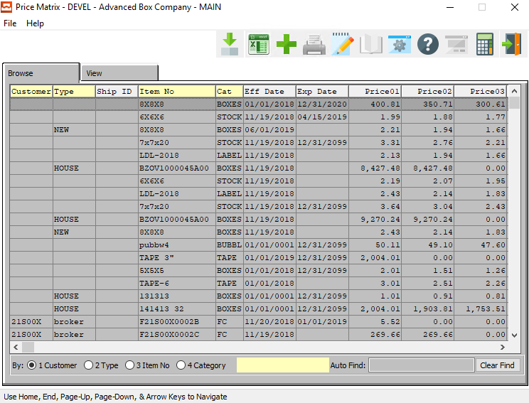

## Step Ten: Purchase Order File Maintenance

Purchase Order File Maintenance programs are located under the [***“P”-“F”***] hotkeys.

### Purchasing Control File

The *P/O Control* screen is located in the following Menu Path: Purchasing -> File Maintenance for Purchasing -> Purchase Order Control Menu. Alternatively, the user can quickly get to this screen using the Hot Key combination: ***[“P” – “F” – “2”]***.

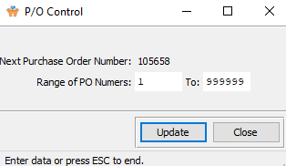

### Reject Reason File

The *Rejection Codes* screen is located in the following Menu Path: Purchasing -> File Maintenance for Purchasing -> PO Rejection Codes. Alternatively, the user can quickly get to this screen using the Hot Key combination: ***[“P” – “F” – “1”]***.

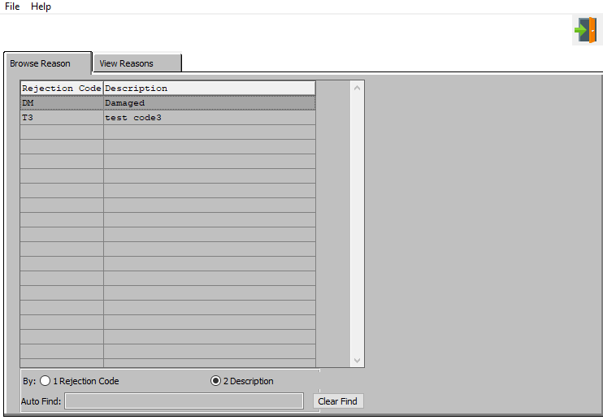

## Step Eleven: Job Cost Control File

### Job Cost Control File

The *XXX* screen is located in the following Menu Path: Job Costing -> File Maintenance for Jobs -> Job Cost Control. Alternatively, the user can quickly get to this screen using the Hot Key combination: ***[“J” – “F” – “2”]***.

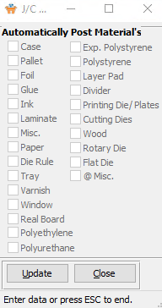

### Product Line File for General Ledger Accounts

Please Note: This is only required in posting General Ledger entries by Job.

The *Product Line GL Accounts* screen is located in the following Menu Path: Job Costing -> File Maintenance for Jobs -> Product Line GL Accounts. Alternatively, the user can quickly get to this screen using the Hot Key combination: ***[“J” – “F” – “3”]***.

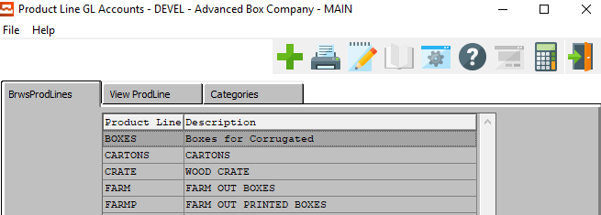

### Machine Charge Code File

The *Machine Charge Codes* screen is located in the following Menu Path: Job Costing -> File Maintenance for Jobs -> Machine Charge Codes. Alternatively, the user can quickly get to this screen using the Hot Key combination: ***[“J” – “F” – “1”]***.

